čt 25.7.2019 13:09

SANTE-ADNS-SUPPORT@ec.europa.eu

SLOVAKIA '11 African swine fever in domestic pigs' - Primary disease notification

|  |  |
| --- | --- |
| Country of origin | SLOVAKIA |
| Disease | African swine fever in domestic pigs |
| Serial number of outbreak (year/number) | 2019/1 |
| Type of outbreak (primary '1' or secondary '2') | 1 |
| Region affected | 00032 Trebisov |
| Traces LVU code | 03300 - Trebišov |
| Latitude | 48.36 |
| Longitude | 21.87 |

Origin of disease : Unknown - investigation continuing  
  
**Control measures :**  
     - 32 DEST OUT  
     - 50 MOVE CONTRL  
     - 10 TOT SL IN  
  
**Date**  
Date of suspicion of disease on holding (day/month/year) : 23/07/2019  
Date of confirmation of disease on holding (day/month/year) : 24/07/2019  
Date of completion of killing (day/month/year) : 25/07/2019  
Date of completion of destruction or rendering (day/month/year) : 25/07/2019  
  
**Number of animals**  
Number of susceptible animals on holding  
     - pigs : 4  
     - wild species : 0  
Number of animals affected on holding  
     - pigs : 1  
     - wild species : 0  
Number of animals that have died of the disease on holding  
     - pigs : 0  
     - wild species : 0  
Number of animals killed on holding  
     - pigs : 4  
     - wild species : 0  
Number of carcasses destroyed or rendered  
     - pigs : 4  
     - wild species : 0  
     - Number and type of pigs on the infected holding fattening pigs : 4  
Method used for diagnosis : 88  
     - Number and type of pigs affected on the holding fattening pigs : 1  
  
Date of dispatch (day/month/year) : 25/07/2019  
Time of dispatch (24-hour clock) : 12:27  
  
Comments : Non commercial farm, diagnostic laboratory method used - PCR

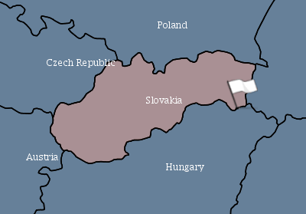

|  |
| --- |
| Disclaimer:  the location of the outbreak is not exact for privacy and protection of data reasons. The coordinates have been reduced to 2 digits after the comma so that the location shown on the map is not the exact location of the holding affected. |